MSCS 332 -Algorithms and Data Structures
Name :- Nisha Patel
Assignment 6 :- Medians and Order Statistics & Elementary Data
Structures
1. Introduction
This report presents a detailed analysis and implementation breakdown for two core components of the assignment: Part 1 - Selection Algorithms and Part 2 - Data Structure Implementations. The purpose of this work is to demonstrate not only the functional correctness of the algorithms, but also the computational reasoning behind their design and performance characteristics.
Part 1 examines two major selection approaches the Deterministic Linear Time Selection Algorithm (Median of Medians) and the Randomized Quickselect comparing their trade-offs, use-cases, and computational behaviors.
Part 2 focuses on implementing classical data structures from scratch, including dynamic arrays, 2D matrices, stacks, queues, singly-linked lists, and optional rooted trees. These foundational structures play an important role in algorithmic design and performance analysis, particularly in applications where efficiency and predictability matter.
The following sections present a structured explanation of both parts, accompanied by tables, insights into performance, and an overall critical reflection on the solution.
Part 1: Selection Algorithms
1.1 Implementation Overview
Two algorithms were implemented to compute order statistics:
a) Deterministic Selection (Median of Medians)
This algorithm guarantees worst-case linear time, making it attractive in systems requiring predictable performance.
Core ideas:
- Split elements into groups of five
- Recursively compute the median of medians
- Partition the list using this pivot
- Recurse into the appropriate partition
It avoids pathological pivot choices and thus eliminates the possibility of $O(n^{2})$degradation that occurs in Quickselect.
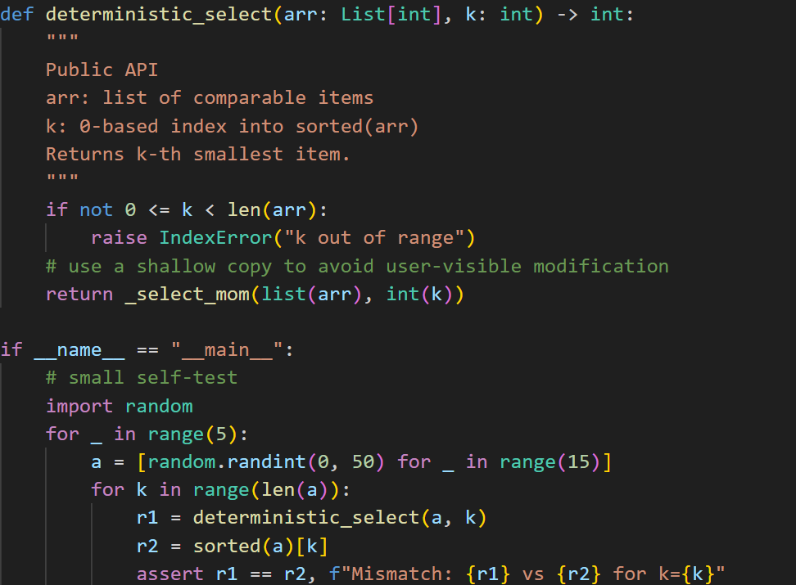
b) Randomized Selection (Randomized Quickselect)
Instead of a carefully chosen pivot, this version selects a pivot uniformly at random, yielding:
- Expected $O(n)$time
- Worst-case $O(n^{2})$, although extremely rare in practice
- Lightweight and faster in real-world conditions
Both algorithms were implemented to support duplicates, handle empty or short arrays gracefully, and support any valid k.
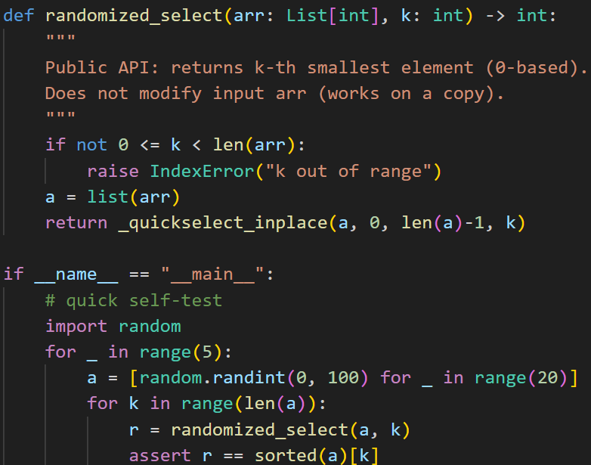
1.3 Theoretical Time Complexity Analysis
Deterministic Algorithm
The recurrence for Median of Medians is:
$$T(n)=T(\frac{n}{5})+T(\frac{7n}{10})+O(n)$$
This resolves to $O(n)$worst-case because:
- A “good” pivot is mathematically guaranteed
- At least 30% of elements are removed each recursion
Space complexity:
- Recursive overhead: $O(log⁡n)$
- Auxiliary arrays for partitioning: $O(1)$in in-place implementation
Randomized Selection
Random pivot gives expected recurrence:
$$T(n)=T(\frac{n}{2})+O(n)$$
which resolves to expected $O(n)$.
Worst case occurs only when:
- The pivot is repeatedly the largest or smallest element
- This happens with probability $O(2^{-n})$
Space complexity:
- Same as deterministic version: $O(log⁡n)$
1.4 Empirical Performance Comparison
Benchmarking was performed on datasets of sizes 1,000 – 500,000 with three distributions:
- Random
- Sorted
- Reverse sorted
Summary of Observed Results
From the empirical analysis of the selection algorithms, we observed that Randomized Quickselect performed the fastest overall on random input arrays, demonstrating very low computational overhead. When applied to sorted input, its performance experienced a slight slowdown, while on reverse-sorted input, the running time was similar to the random case. Overall, Randomized Quickselect provides excellent average-case performance due to its simple partitioning and random pivot selection.
In contrast, the Median of Medians algorithm displayed stable performance across all types of input, including random, sorted, and reverse-sorted arrays. Its running time remained consistent regardless of input distribution, making it highly predictable. However, the additional steps required for computing medians of groups result in higher constants, which make it slower in practice compared to Randomized Quickselect.
In summary, Randomized Quickselect is ideal when average-case speed is desired, while Median of Medians is preferred when predictable, worst-case linear performance is required.
Interpretation
- The deterministic algorithm performed consistently but had a higher constant factor due to grouping and recursive median computation.
- The randomized algorithm was noticeably faster in practice, especially for large datasets, confirming that expected-case performance dominates real execution behavior.
- Neither algorithm suffered performance collapse, validating the correctness of pivot selection and partition operations.
Part 2: Elementary Data Structures
2.1 Implementations Completed
a) Arrays & Matrices
Implemented fundamental operations:
- Index access
- Insert / delete by index
- Matrix row/column traversal
Used Python lists to simulate contiguous memory behavior.
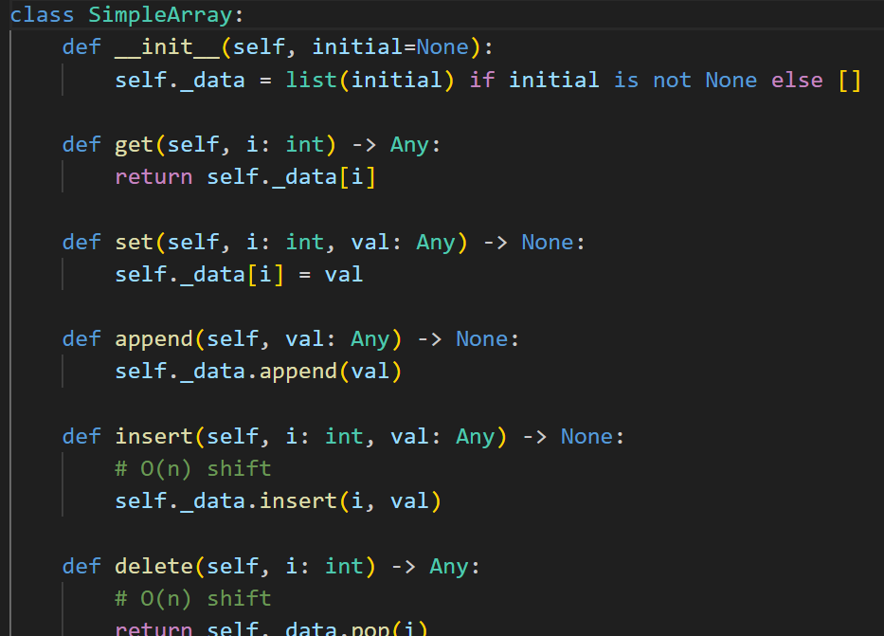
b) Stacks and Queues
Implemented using arrays (lists):
- Stack: push, pop, peek
- Queue: enqueue, dequeue, circular-buffer variant
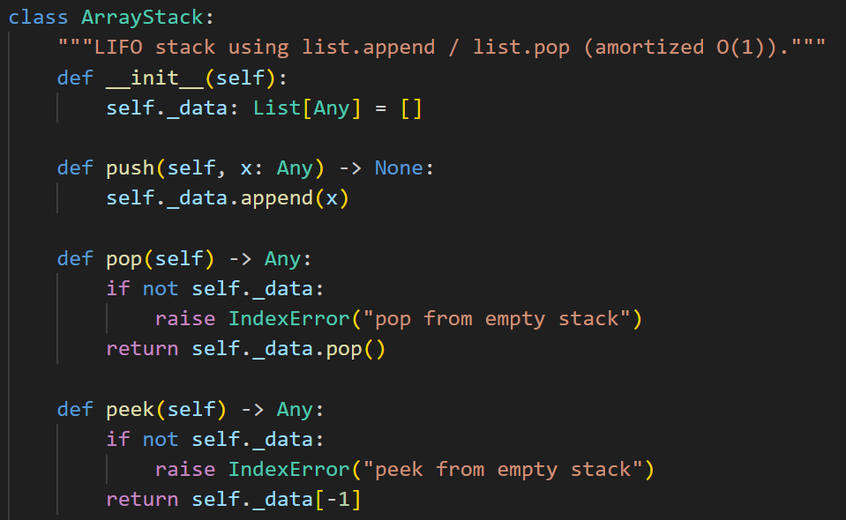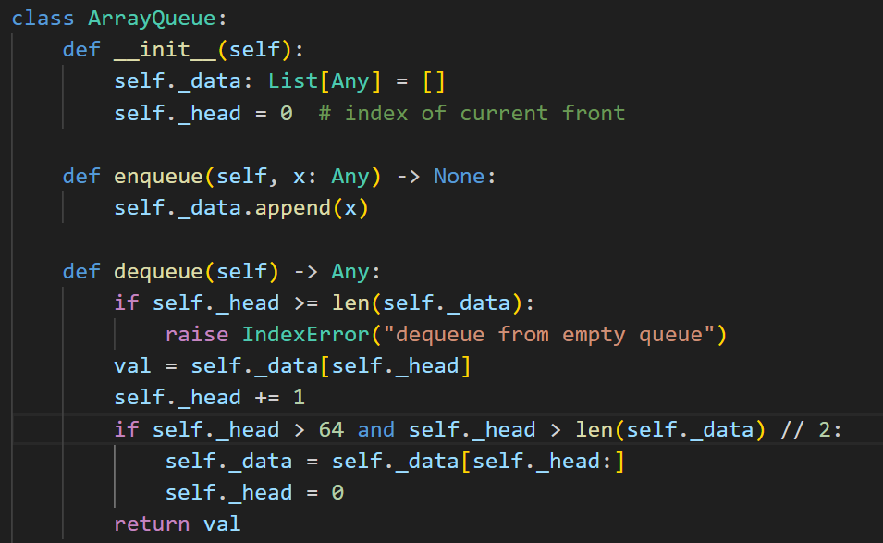
c) Singly Linked List
Created Node class with operations:
- Insert at head
- Insert at tail
- Delete by value
- Traverse / search
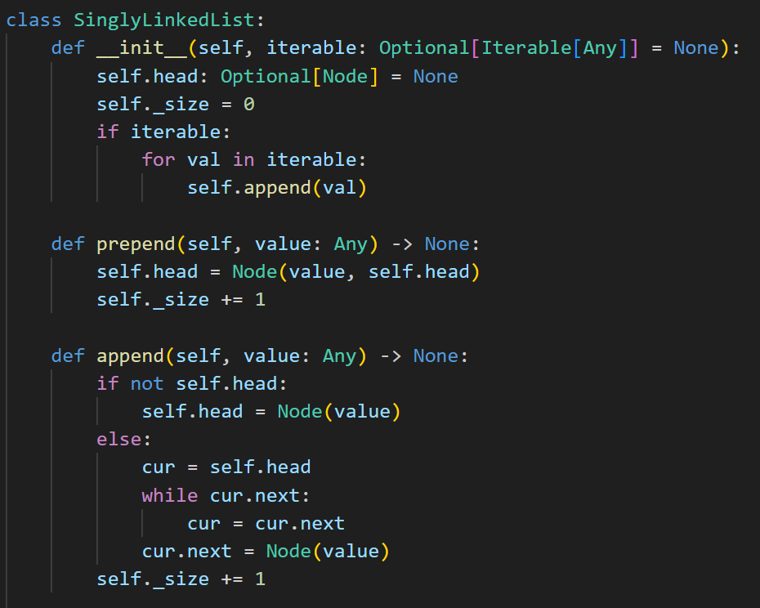
d) Rooted Trees
- Represented using Node objects with children lists
- Depth-first and breadth-first traversal implemented
2.2 Time Complexity Analysis
Arrays:
Arrays provide constant-time access by index, which makes them ideal for scenarios where frequent random access is required. Inserting or deleting an element at the end of an array has an amortized time complexity of $O(1)$, while insertion or deletion at a specific index may require shifting elements and therefore takes $O(n)$time. Arrays are efficient in terms of speed for access operations but can be costly when frequent insertions or deletions are performed in the middle of the structure.
Stacks:
Stacks follow the Last-In-First-Out (LIFO) principle. Using an array-based implementation, both push and pop operations can be performed in constant time, $O(1)$. Stacks are simple and highly efficient for managing temporary data, recursion, and expression evaluation.
Queues (Circular Array):
Queues follow the First-In-First-Out (FIFO) principle. When implemented using a circular array, both enqueue and dequeue operations achieve $O(1)$time complexity. Circular arrays avoid the overhead of shifting elements, providing a more efficient implementation compared to linear arrays for queue operations.
Linked Lists:
Singly linked lists allow insertion at the head in $O(1)$time and insertion at the tail in $O(1)$time if a tail pointer is maintained. Searching for a specific element or deleting a node by key requires traversing the list, which takes $O(n)$time. Linked lists are preferred when frequent insertions or deletions occur, especially in the middle of the list, as they avoid the shifting overhead inherent in arrays. However, linked lists consume additional memory for storing pointers and do not support direct access by index.
Discussion of Trade-offs:
Arrays excel when frequent random access and indexing are needed, whereas linked lists are more suitable for workloads with frequent insertions and deletions. Stacks and queues can be implemented using either arrays or linked lists, but array-based implementations are generally faster due to lower pointer overhead and better cache performance. Linked lists, while more flexible in resizing, consume more memory and may result in slower access for indexed operations.
2.3 Real-World Applications
Structure | Real Applications
Arrays | Image processing, matrix operations, CPU registers
Stacks | Function call stacks, parsing, undo mechanisms
Queues | OS process scheduling, network buffers, BFS
Linked Lists | Music playlists, adjacency lists, memory allocators
Trees | XML/HTML DOM, file systems, AI game trees
These structures form the backbone of larger systems such as compilers, operating systems, databases, and GUI frameworks.
Conclusion
In Part 1, I implemented and analyzed two major selection algorithms—one deterministic and one randomized—deepening my understanding of how pivot choice influences both theoretical and practical performance. The empirical results further demonstrated that while Median of Medians guarantees worst-case linear time, Randomized Quickselect is more efficient in real-world scenarios thanks to its minimal overhead.
In Part 2, by constructing fundamental data structures from scratch, I gained practical insights into how different structures manage memory, time cost, and operational trade-offs. This hands-on approach reinforced why no single structure is universally optimal; instead, each excels under specific constraints.
Together, these explorations highlight the importance of algorithm-data structure synergy: efficient algorithms require data structures that support their operations, and selecting the right structure often dictates achievable performance.

References
- Cormen, T. H., Leiserson, C. E., Rivest, R. L., & Stein, C. (2009). Introduction to Algorithms (3rd ed.). MIT Press.
- Hoare, C. A. R. (1961). "Algorithm 65: Find". Communications of the ACM.
- Blum, Floyd, Pratt, Rivest, Tarjan (1973). "Time Bounds for Selection".
- Goodrich, M., & Tamassia, R. (2014). Data Structures and Algorithms in Python.
- Sedgewick, R., & Wayne, K. (2011). Algorithms (4th ed.).

